**ABSTRACT**  XY PLOTTER

**INTRO:**

A Plotter used to produce hardcopy of Images, graph, maps, architectural plans and even Braille signs for blind people.

**Requirements**:

Hardware: Software:

* Arduino, To convert image of .jpg to .cnc.
* Stepper motors, Arduino and Processing IDE
* Stepper motor drivers,
* Beam
* Shaft,
* Timing belt, pulleys, etc.

**Outline:**

Image(softcopy)🡪computer numerical code or gcode🡪analyze code using Arduino and motor driver🡪control pen via stepper motor connected to arduino🡪Image(hard copy).

**Procedure:**

**Mechanical part:**

Everything starts from building the frames needed for holding the motors of corresponding x and y axis.

A square wooden frame is made and a horizontal beam is placed on the sides of square frame.

The square frame is kept stationary so that the horizontal y axis frame is made to move through the frame.

Now a pen holder is fitted in the moving horizontal frame.

The horizontal frame (y axis) will be moving left to right and vice versa on the square frame.

The pen holder will move up and down, vice versa on the horizontal (y axis) frame.

Now motor for the y axis movement (horizontal frame) is placed in the stationary square frame. This motor moves the horizontal y axis frame using the timing belt.

Then the motor for movement of pen holder is now placed in the moving horizontal frame. (See below image for reference).

This motor moves the pen by which the image is drawn on the paper kept below.

Now the motors do their corresponding linear motion according to the respective given commands.

The stepper motors are connected to the drivers and arduino.

**Electronic part:**

A 2d image is converted to Gcode so that the computerized machine tools could understand.

**Gcode is nothing but a numerical control programming language used to control automated machine tools.**

This Gcode contains instructions on where to move, how fast to move, and what path to move.

The machine tool (pen) moves according to this instructions and draw the image.

The Gcode generator software generates Gcode of our desired image.

Then the Gcode is transferred to processing ide where it is parsed and fed to arduino which will analyze the Gcode by the interpreter program uploaded before.

Interpreter program is a program used to drive motors using given information.

And send signal commands to respective stepper motor drivers and direct stepper motors having pen which does the goal of drawing and etc.,

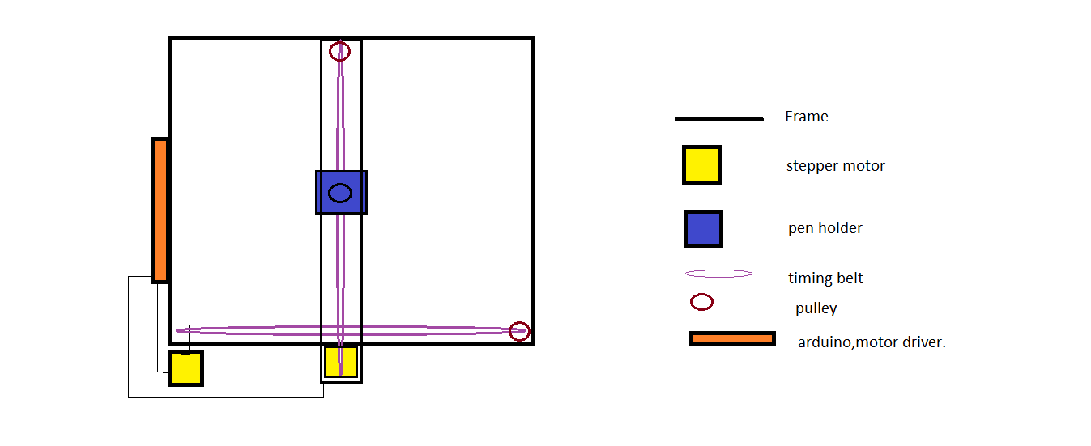

(Sorry for the low quality image)

**Advantages**:

* Maintain resolution of images even at large size
* Replacing pen by suitable cutter enables to create logos on glasses (preview) for designers.
* Reproducibility and Accuracy.
* Can be converted to create Braille signs for visually challenged.

**Disadvantages:**

* Large size
* High cost (but aim is to create a low cost tool).

**Conclusion:**

Aiming to produce a CNC tool capable of accurately precisioned

* Drawing(pen),
* Cutting(razor blade),
* Engraving(laser),
* Creating BRAILLE.

**Team Members** (2nd yr)**:**

Nikhil Sabari Askar kani

Anish christo Arul Muthusamy.